**Classes used**

**Auto.java:**

Auto.java is responsible for setting up the selenium webdrivers used to connect to Mysoft

**WorktagUpdate.java:**

WorktagUpdate.java is responsible for using mysoft to search the jacks and grab the worktags

**Readexcel.java:**

Readexcel.java is responsible for reading and writing to the excel file

**Running the project**

**Running Auto.java**

The first time you run Auto.java you will need to do this. Expand the WorkA project in the file explorer, expand the src folder, and the expand the workA folder. Right click on Auto.java and then click run as java application

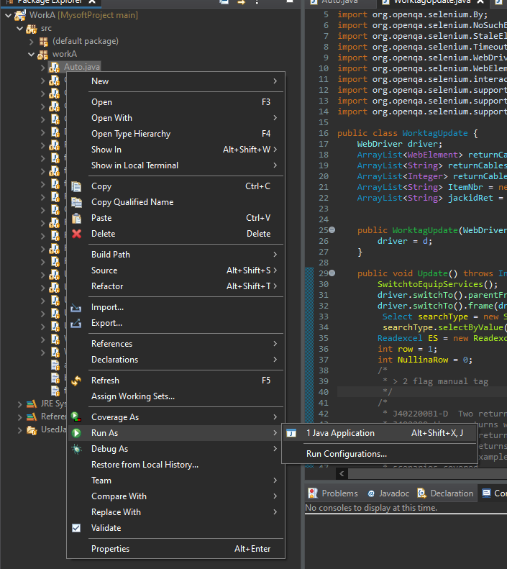

After doing this the first time Eclipse will remember this is where your main class is located and you can press on the green button in the picture below

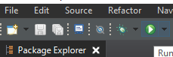

Once this class starts running you’ll notice you have popups in your console

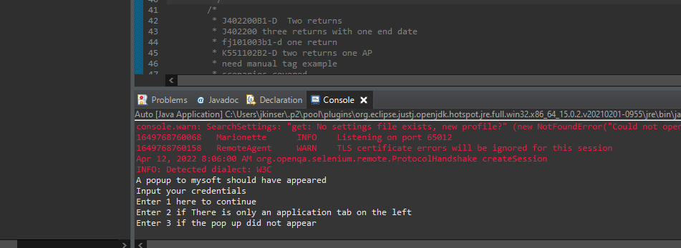

If you do not see your console please follow this guide

<https://qawithexperts.com/questions/273/how-to-open-console-in-eclipse>

You will also notice firefox opened a mysoft window. Enter your credentials and do not press anything else once in mysoft. Think of the mysoft window as split up into separate windows. If you were to click on equip/services the program would be thrown off as it would have expected to be in a different window.

*Note: sometimes mysoft will show a not authorized page. Simply refresh the page and it will show the credentials box

Take note of the options presented above. Sometimes mysoft will open to a window you are not familiar to. The only option shown in the box on the left will be application. If this happens Press 2 and then enter. If you are presented with a familiar Mysoft screen type 1 and press enter.

A normal mysoft screen

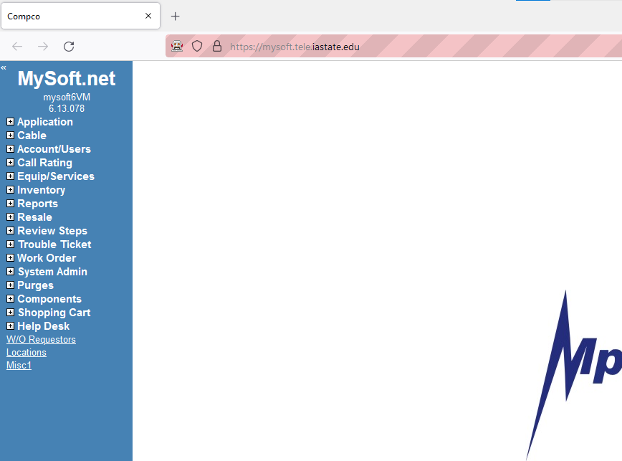

Back in your console you will then be presented with different options for classes to run. For grabbing worktags enter 2 and then the enter key

You will notice your firefox window switched to equip/services

Now you will enter in the file path information to the excel file. If you store your files within the Bulk import folder located in the project. Your file path will look similar to this. A few notes on your file

* Make sure this isn’t your only copy of the cut sheet. Although not common, The readexcel library is not perfect and can sometimes corrupt the file
* Don’t have spaces in the filename

DriveLetter:/Documents/workRepo/MysoftProject/BulkImport/Filename.xlsx

Then enter the sheet name *It is recommended that your sheet name has no spaces in it*



Then enter the column letters for the jackID and where the program can put the notes

A few notes for this columns

* Make sure the note column is empty. Any data in that column will be overwritten
* Readexcel assumes the first row is dedicated to a header
* Make sure the jacked is not concatenated from other cells. Read excel will not be able to read these columns correctly
  + Ex

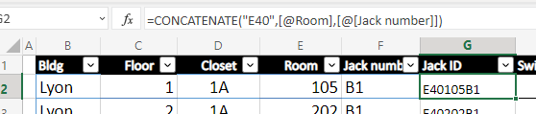

* + Make a new column and copy the jackID column by value
    - 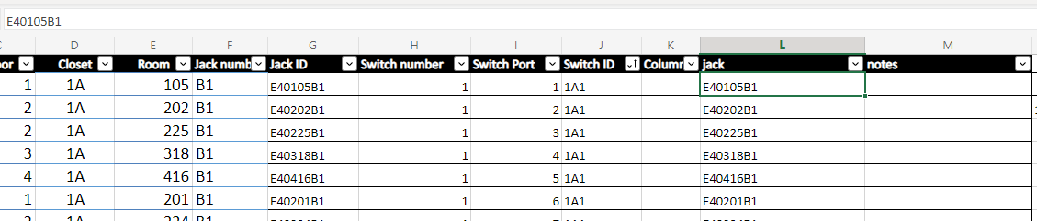Ex
* It does not matter if your jackID has -D or not, or is all uppercase or lowercase

Now, using the picture above. Your jackID column will be L and your notes column is M. Before pressing enter, make sure the excel file is closed. Readexcel cannot read and write to a file that is in use with another operation.

The console will then ask you to confirm the first values of your columns. Enter y if everythings looks fine. Pressing n will have you enter the information above again.

The program will then start looping through the rows. You will be able to tell the program is done when it reads terminated like the picture below.



Last note: This code is not perfect, errors may happen. I have tried to modify the code to catch all the errors I’ve encountered. Although some errors may occur that I have never seen. Try using the modifying the code doc to help understand the code